16

inner structure of kayak technique
imre kemecsey
============================================================================================

POWER CIRCLE #1 / PICTURE 4

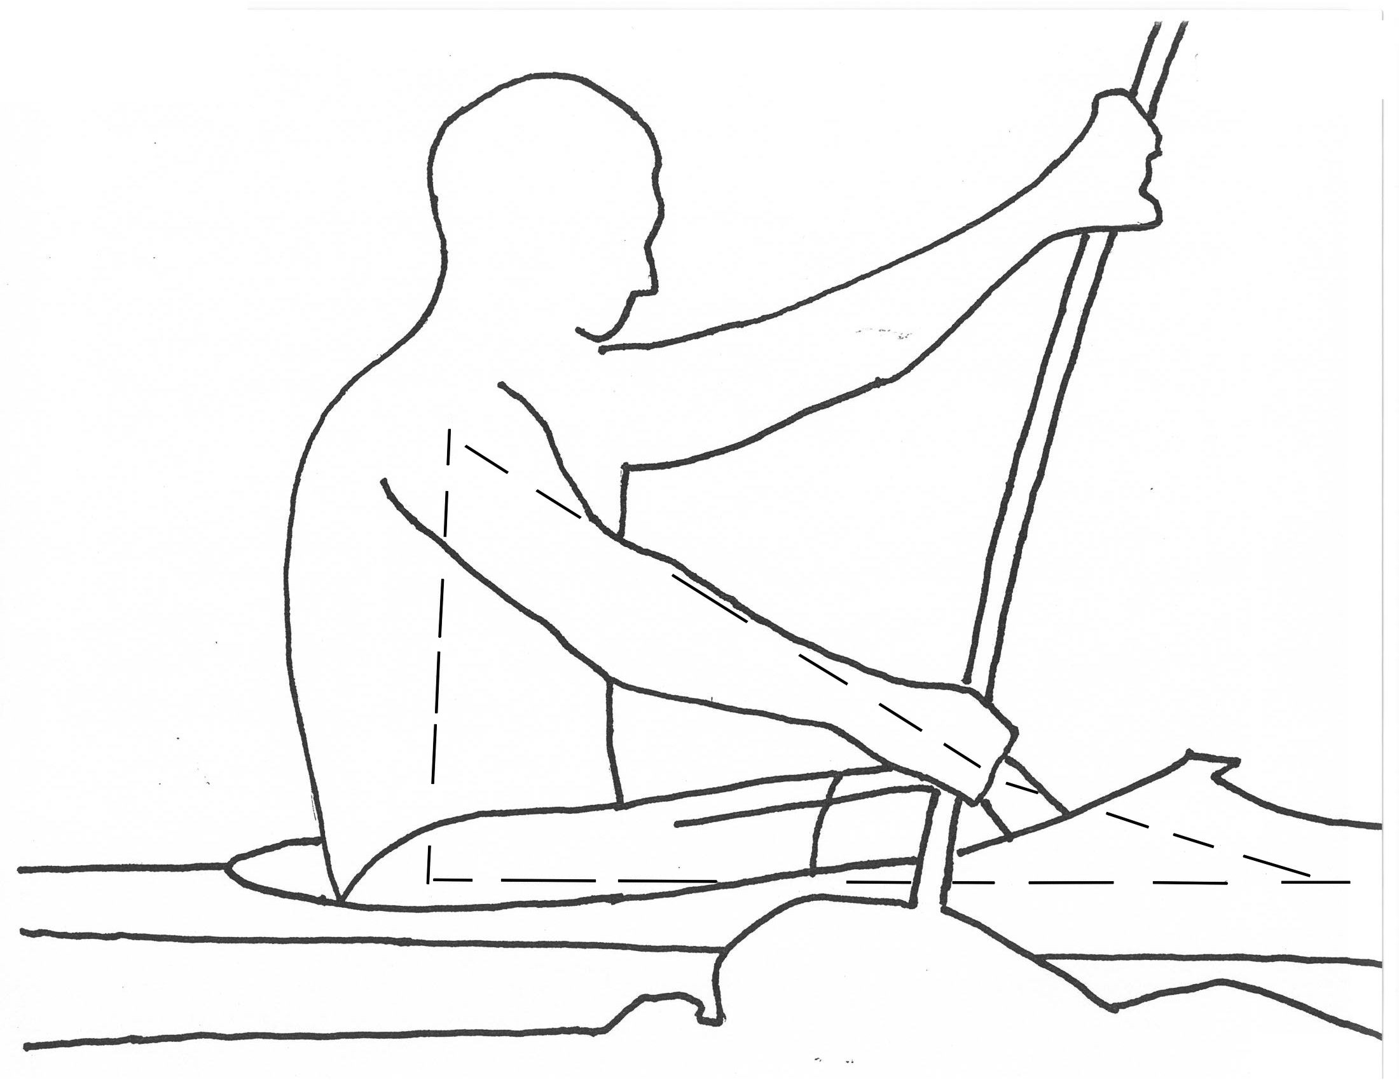

Practically this Power Circle is nothing else but a side-view of kayaking.

It is apparent that this Power Circle can be described almost only in 2D. It is hard to figure out what is happening on the support side by analyzing it. What is important for us now is that this Power Circle is “responsible” for good or bad catch.

→ foot board on the pulling side → straightening, contracting leg → hip → trunk muscles on the pulling side → pulling arm, hand → “back” to the foot board on the pulling side

Compression: contracting leg → hip → trunk on the pulling side

Tension: pulling arm

For me, it is very important that compression is present in all power circles. They all help to increase the tension in the pulling arm. Tension is present only in the pulling arm in PC #1 and PC #2. The upper arm bends the shaft forward. All the other parts of the body support this work. After practicing the power circles for a few weeks, all details are automatically “put together” to “serve” the pulling arm. It is not about holding the elbow too high or too low or doing poor or too much legwork. The rotation of the trunk that differs with each athlete is also “set” and the balance of the athlete improves significantly.

PRACTICING: The “tug-of-war” image. The trunk is supported by the heels, the arms are in their natural position. This is how we hold on to end pulling a rope.
17

inner structure of kayak technique
imre kemecsey
============================================================================================

POWER CIRCLE #2 / PICTURE 4

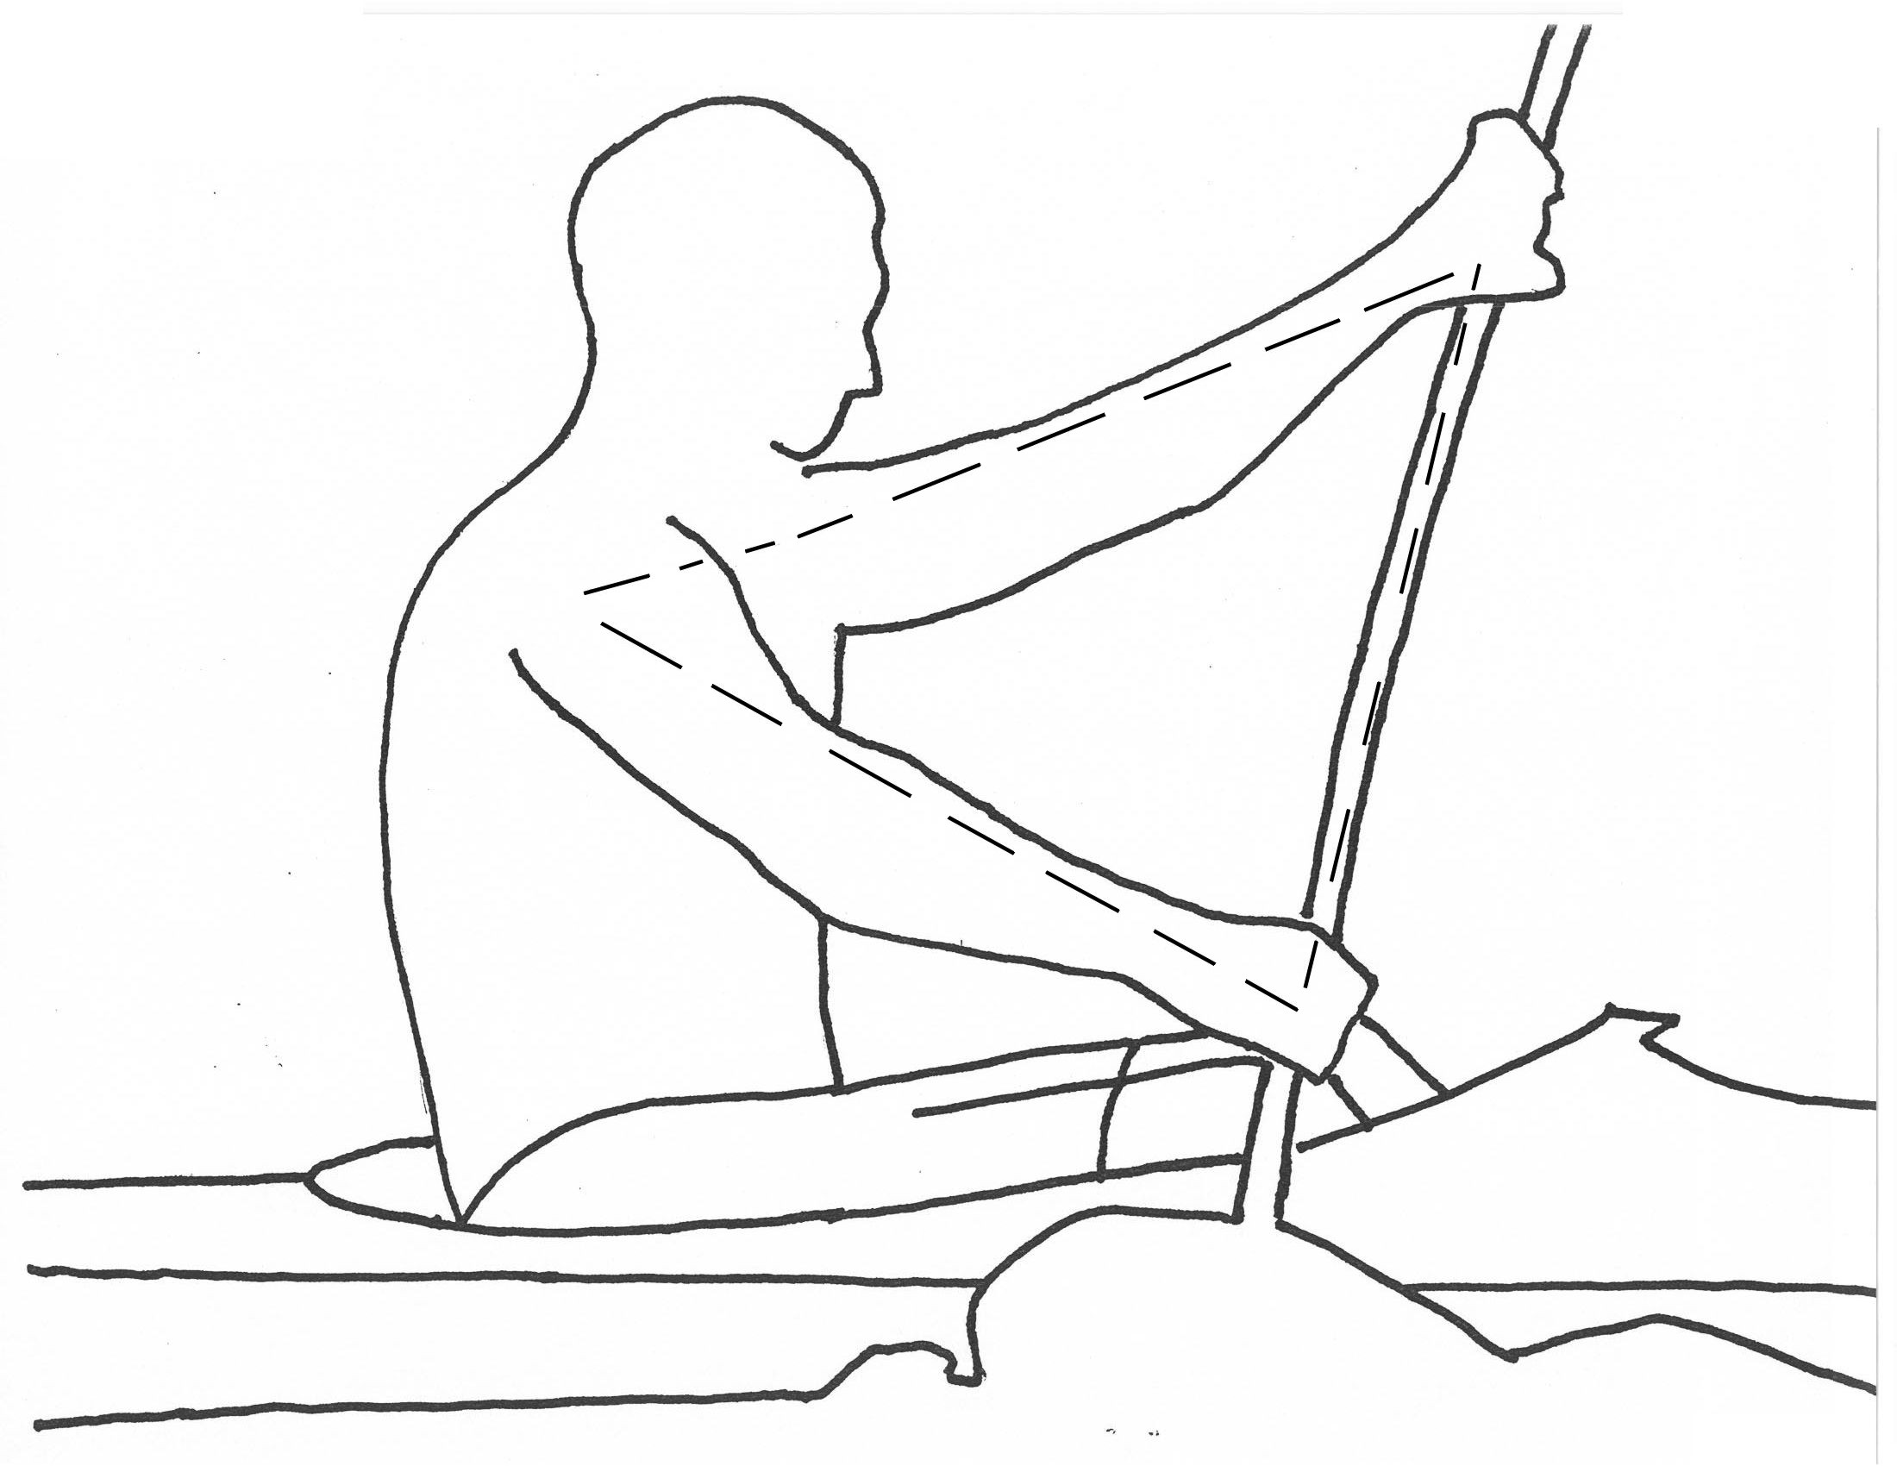

Power Circle #2 starts at the shoulder on the pulling side, goes to the shoulder on the support side then through the supporting arm, hand and the shaft and back to the shoulder through the pulling arm and hand.

“What helped me most to understand it was the image that my arms, shoulders and the shaft are all covered or coated with plastic membrane. If I bend my arms or change the angles between my shoulders and upper arms too much the membrane gets creased …and this is not good.”

Power circle #2 can be taught and learnt fast by using the membrane image even at the age of 10. If we go back a few decades in the history of kayaking we find that L. Nagy, E. Hansen and Z. Bako also included this power circle in their technique. Today all great kayakers seem to use it.

Power Circle #2: the technique is seen from above

Compression: shoulder on the pulling side → shoulder on the support side → arm

Tension: pulling arm

PRACTICING: arms; shoulders; shaft are covered with „Saran - Wrap”
18

inner structure of kayak technique
imre kemecsey
============================================================================================

POWER CIRCLE #3 / PICTURE 4

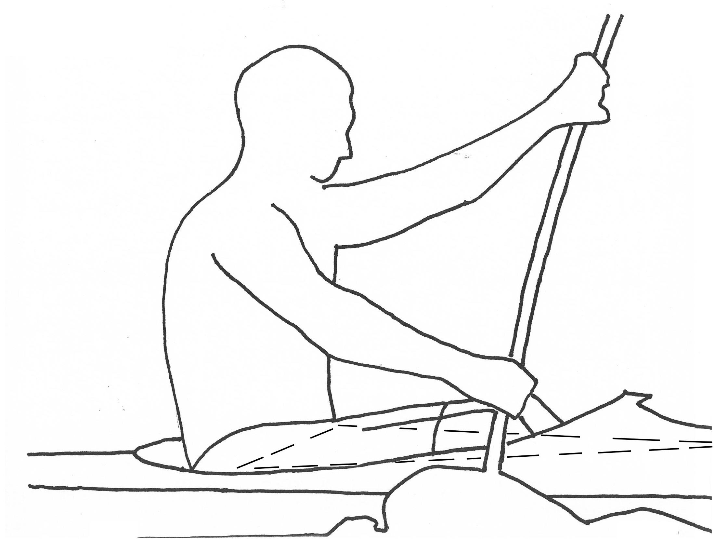

→ foot board on the pulling side → straightening, contracting leg → hip on the pulling side → hip on the support side → “back” to the foot board on the pulling side

Seen from above.

Compression: straightening and contracting leg → hip on the pulling side
→ hip on the support side → “back” to the foot board on the pull side

Tension: none in this power circle

The first thing is to practice and improve legwork with the help of PC #3. It is very important because there is no solid “structure” without good legwork.

“Today’s practice felt really good…it was one of my best technical days. As soon as I got on the water and started to paddle I could feel a difference in my stroke, balance and perception of what I’m supposed to be doing. I started using my legs, and the power automatically appeared. I could reach out farther, still not changing the knowledge I already had of keeping hands at eye level, and my rotation was greater. I felt connected, and the boat just flowed freely, gliding through the water. I understand completely about what Imre was talking about when he said to use the water instead of fighting it”.

PRACTICING: a) bycicle; b) press the heel down on the pulling side;
c) hip-flick
19

inner structure of kayak technique
imre kemecsey
============================================================================================

POWER CIRCLE #4 / PICTURE 4

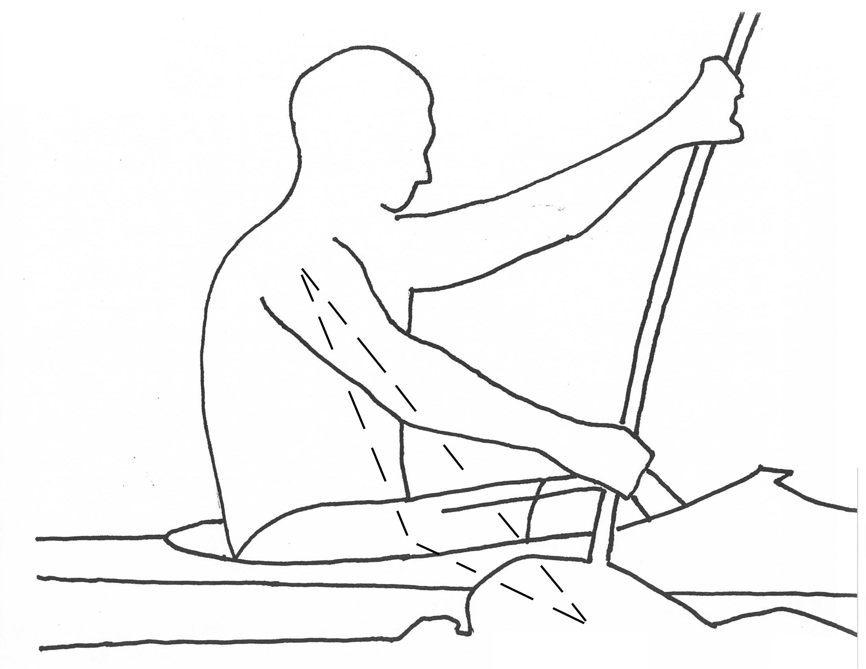

→ blade fixed in the water → shoulder on the pulling side → hip on the support side → “back” to the blade fixed in the water

Compression: blade in the water → shoulder on the pull side → hip on the support side → “back” to blade in the water

Tension: none in this power circle

When watching super kayakers one can see that their trunk is flexible but at the same time holds the structure of technique very firmly and transforms the force into the boat. The first two lines of forces, the one from the blade to the shoulder and the one from the shoulder to the hip on the opposite side, are similar to a carbon fiber rod. They form the shape of an inverted “V”, just like a motion of a penguin or when we are walking on stilts.

The motion of the penguin and walking on stilts are in a way different from kayaking because when paddling it is the two stems of the inverted “V” that support each other from catch, during power phase and till air-work is started. More exactly, the blade in the water is pressing the boat against the water-wall (one stem of the inverted “V” shape) and at the same time, the water-wall at the side of the boat presses the water back (the other stem of the inverted “V” shape).

PRACTICING: pinguin walk
20

inner structure of kayak technique
imre kemecsey
============================================================================================

POWER CIRCLE #5 / PICTURE 4

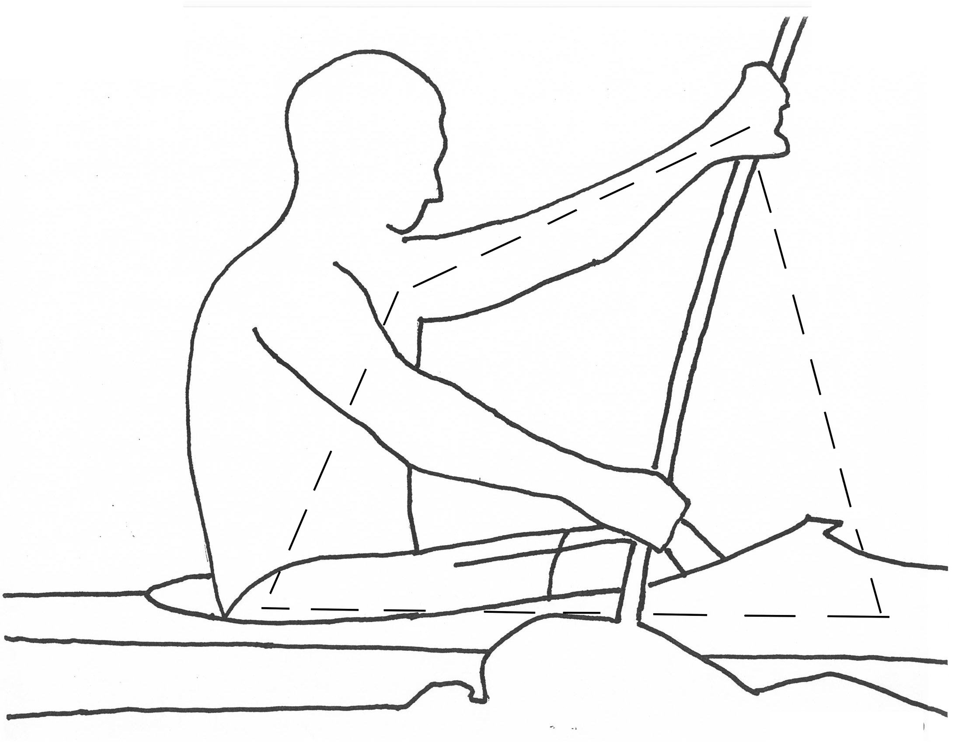

This power circle has two important functions. One is that it can increase the efficiency of Golden Rule #5 that is “powerful support in the water before recovery”. Another is that together with power circle #4 they “link” the arms and shoulders that is power circle #2 with the legs or legwork (PC #3). That part of power circle #4 which goes from the shoulder on the pulling side to the hip on the opposite side is like a thin and flexible carbon-fiber rod. Power circle #5 goes from the hip on the pulling side to the shoulder on the support side, crossing the flexible but in one direction very rigid rod of power circle #4.

These two carbon-fiber rods make it possible for the athlete to maintain a flexible but in the opposite direction rigid “super frame” that is able to support great forces and transform them into speed of the boat later on. The athlete can choose between using and fighting the water. Every boat that lacks proper control fights the water. Like the windsurfer, the water-skier or the skier, the kayaker also has to press the boat a bit sideways. On the one hand, the reaction of the water equalizes the torque created by the paddle so as the boat glide straight forward. On the other hand, the slightly tipped and edged boat settles into the support-side “corner” of the “U” shape created by the wet surface of the boat. Like the bicycle in the “velodromo”. Only because of this edging of the boat can the kayak glide on the real “tread”.

PRACTICING: stretching out leg precisely synchronized with the support arm

