36

inner structure of kayak technique
imre kemecsey
============================================================================================

POWER CIRCLE #1 / PICTURE 4
+
EIFFEL - TOWER

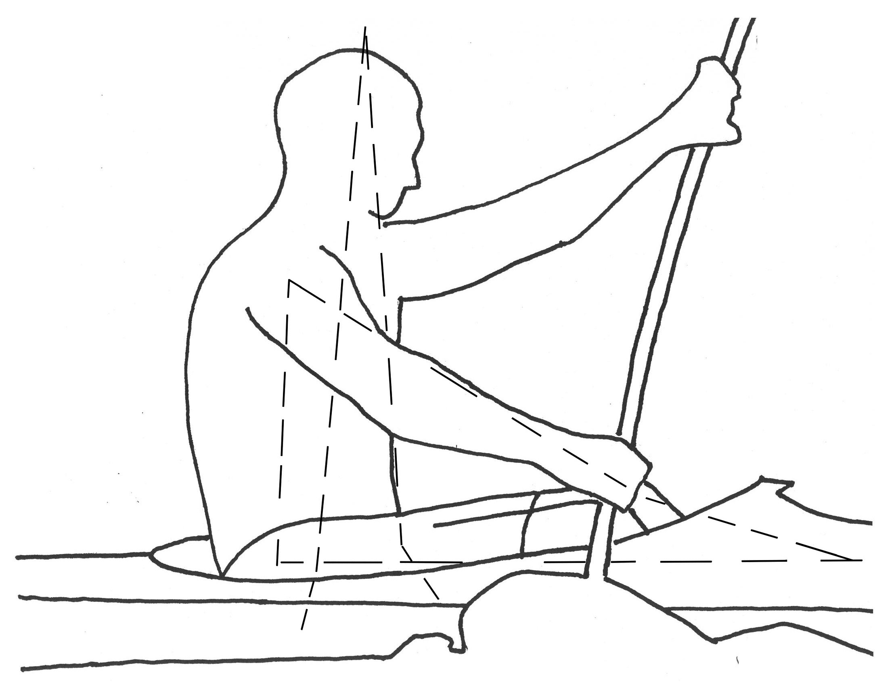
PC #1
→ foot board on the pulling side → straightening, contracting leg → hip → trunk muscles on the pulling side → pulling arm, hand → “back” to the foot board on the pulling side

Compression: contracting leg → hip → trunk on the pulling side

Tension: pulling arm

“I had a new idea about the Power Circles today. It is as if the Power Circles are a frame that fills a sphere, just like that frame (tensegrity) held together with elastic you gave me.”

“After you came though my mindset was up, because of all the new ideas you introduced. I don’t know if they were actually new to me, or just stated them to me in a way I could relate to”

“All the Power Circles work together to keep the tension created to move the paddle, boat & body moving & not bouncing the boat to go anywhere but forward. It is all a process so counterbalancing the tension & force created. If not moved created a negative effect on the boat & efficiency & movement. All parts & segments must be in motion to get movement in the direction you want it to go”.

PRACTICING: separately

37

inner structure of kayak technique
imre kemecsey
============================================================================================

POWER CIRCLE #2 / PICTURE 4
+
EIFFEL - TOWER

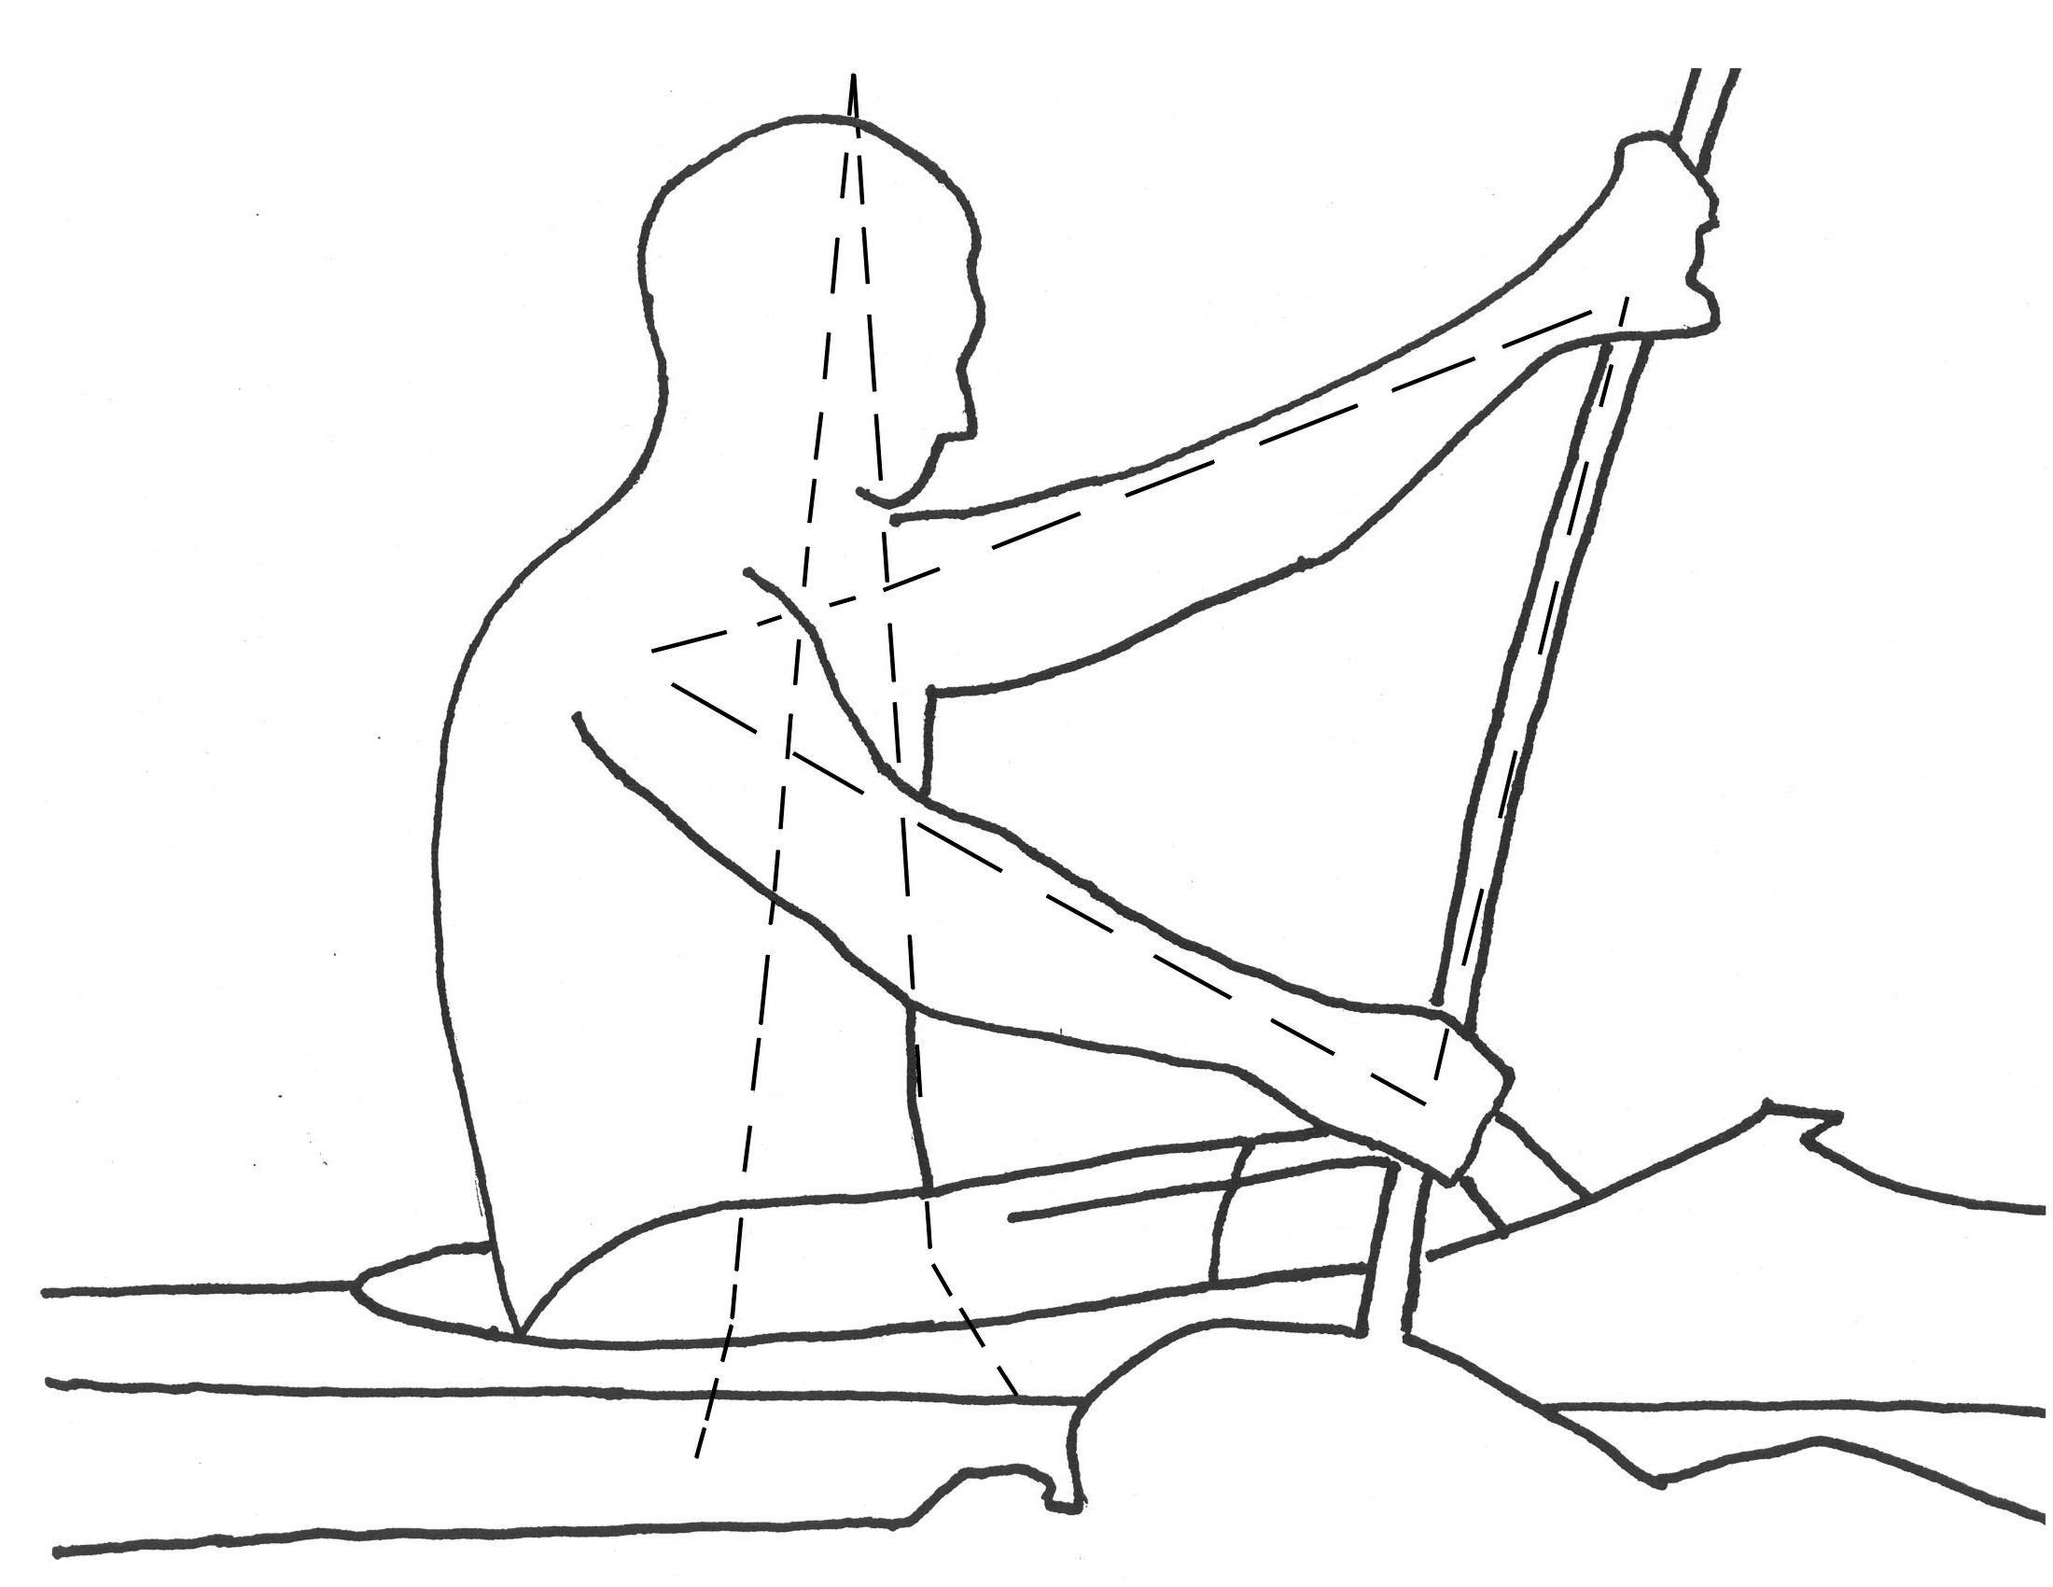

PC #2
→ pulling arm, hand → shoulder on the pulling side → shoulder on the support side
→ supporting arm, hand → through the shaft to the pulling hand
Compression: shoulder on the pulling side → shoulder on the support side → arm

Tension: pulling arm

“Eiffel – Tower: Very good when edging the boat and twisting the boat. Quite hard to visualize at first but once you have, it is very interesting concept. I think rather than A.B.S. it helps the full swing (which is usually a vertically based oscillation) to become more extended. It helps to free the restraints of the full swing and to use energy to compress the water wall rather than to bounce up and down. When you add the torque, you can imagine the tower twisting (like two plates’ #2 & #1). This helps to join the more ridged circles together: you now have an extra picture in your head to use the #4 & #5 more smoothly. The A.B.S. comes into play once you realize that you can twist the tower”.

PRACTICING: separately

38

inner structure of kayak technique
imre kemecsey
============================================================================================

POWER CIRCLE #3 / PICTURE 4
+
EIFFEL - TOWER

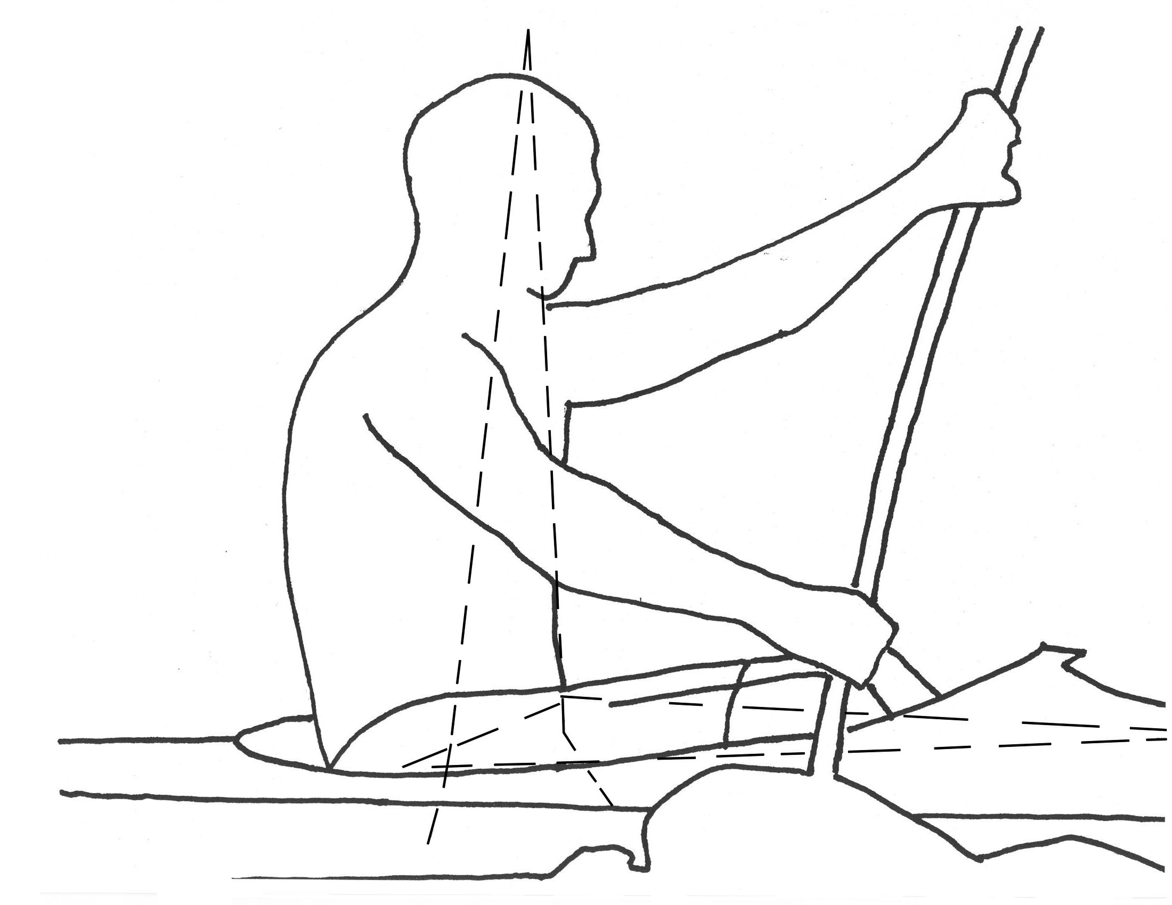
PC #3
→ foot board on the pulling side → straightening, contracting leg → hip on the pulling side → hip on the support side → “back” to the foot board on the pulling side

Compression: straightening and contracting leg → hip on the pulling side
→ hip on the support side → “back” to the foot board on the pull side

Tension: none in this power circle

“This is very much like the Eiffel – Tower. If the Eiffel – Tower was made up on the top of quicksand then it would fall apart. I found this is very useful while I was helping the beginners to start with something basic like PC #2; PC #3, so they could upon it”.

PRACTICING: separately

39

inner structure of kayak technique
imre kemecsey
============================================================================================

POWER CIRCLE #4 / PICTURE 4
+
EIFFEL - TOWER

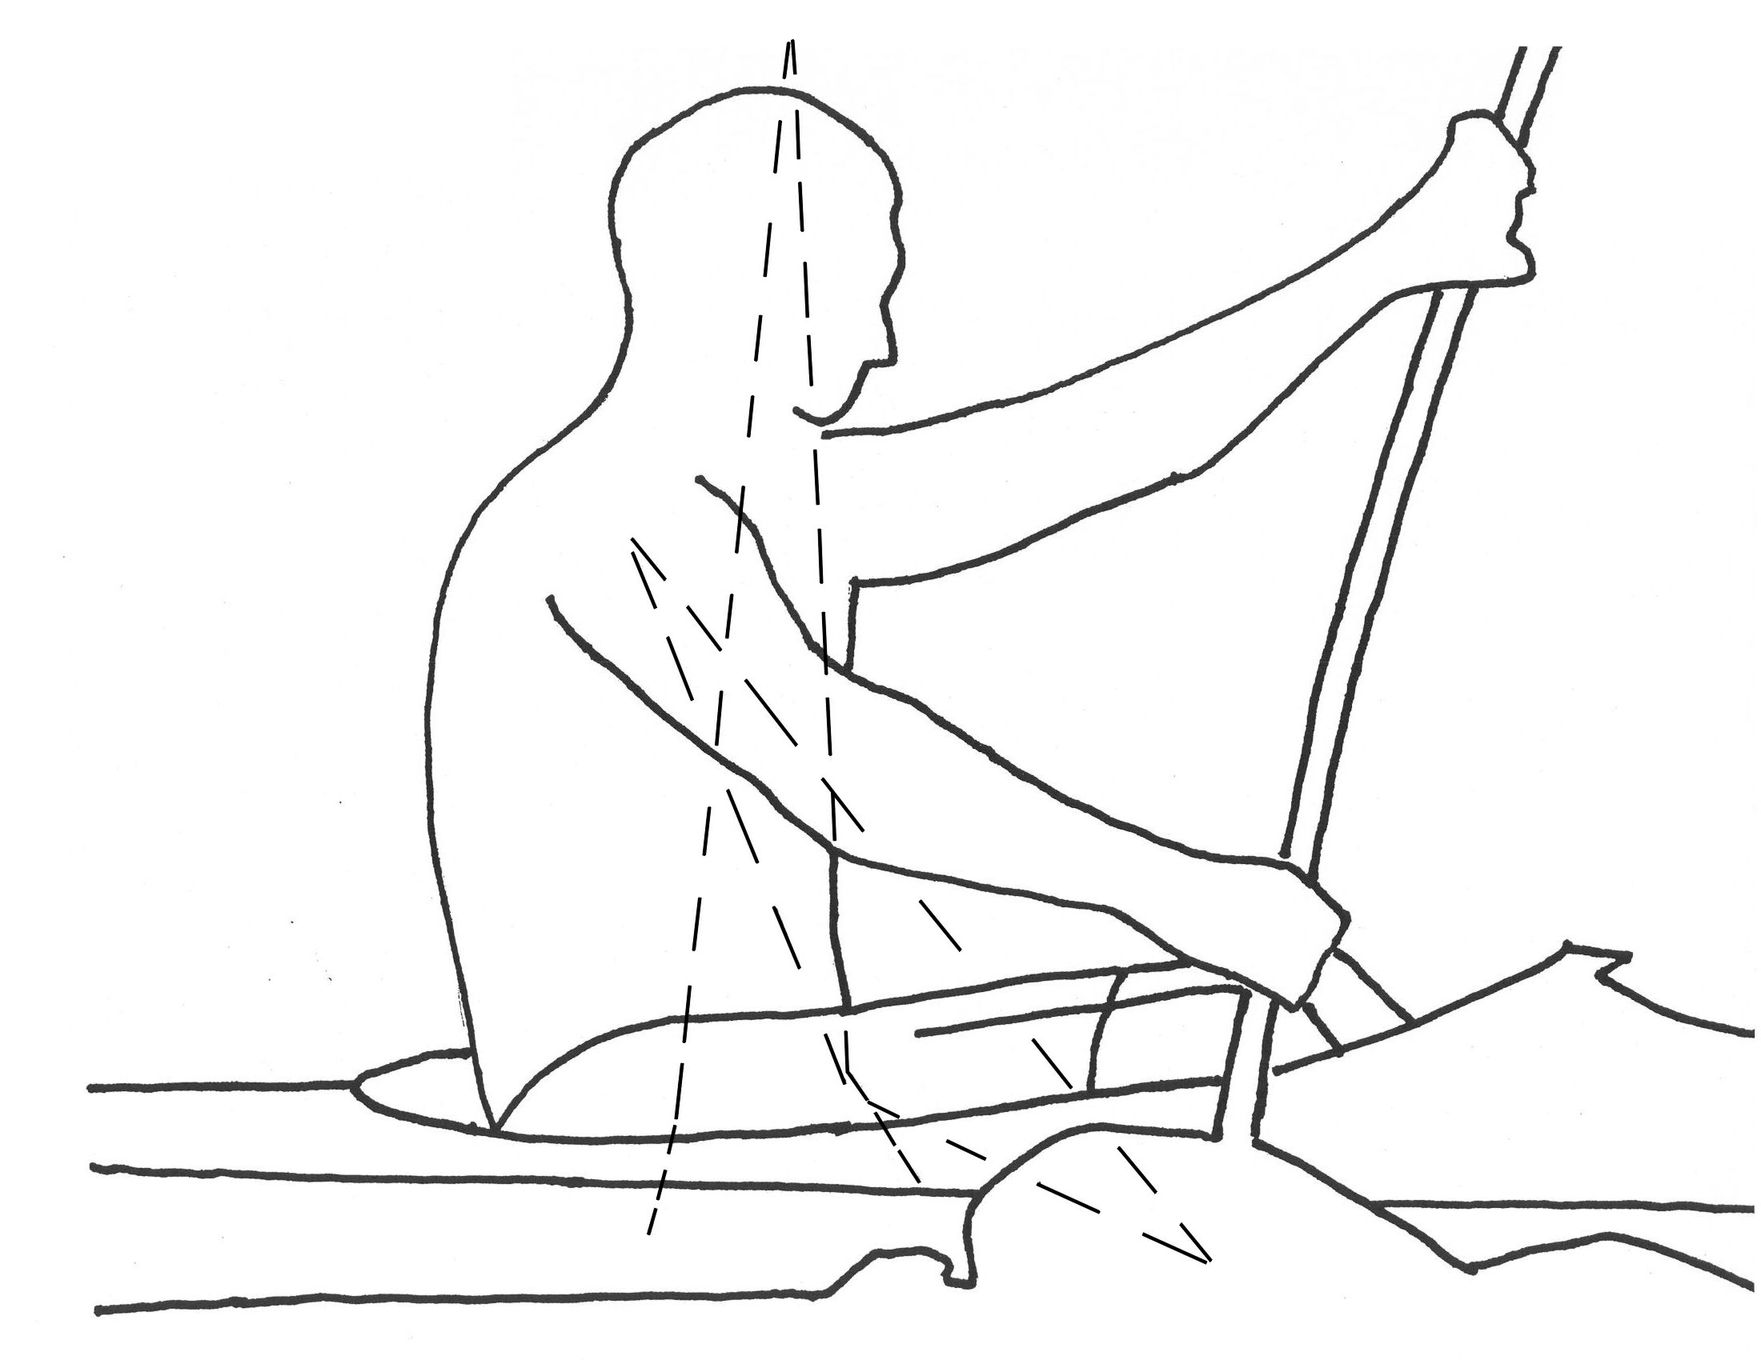
PC #4
→ blade fixed in the water → shoulder on the pulling side → hip on the support side → “back” to the blade fixed in the water

Compression: blade in the water → shoulder on the pull side → hip on the support side → “back” to blade in the water

Tension: none in this power circle

“Eiffel – Tower: Very good when edging the boat and twisting the boat. Quite hard to visualize at first but once you have, it is very interesting concept. I think rather than A.B.S. it helps the full swing (which is usually a vertically based oscillation) to become more extended. It helps to free the restraints of the full swing and to use energy to compress the water wall rather than to bounce up and down. When you add the torque, you can imagine the tower twisting (like two plates’ #2 & #1). This helps to join the more ridged circles together: you now have an extra picture in your head to use the #4 & #5 more smoothly. The A.B.S. comes into play once you realize that you can twist the tower”.

PRACTICING: one by one

40

inner structure of kayak technique
imre kemecsey
============================================================================================

POWER CIRCLE #5 / PICTURE 4
+
EIFFEL –TOWER
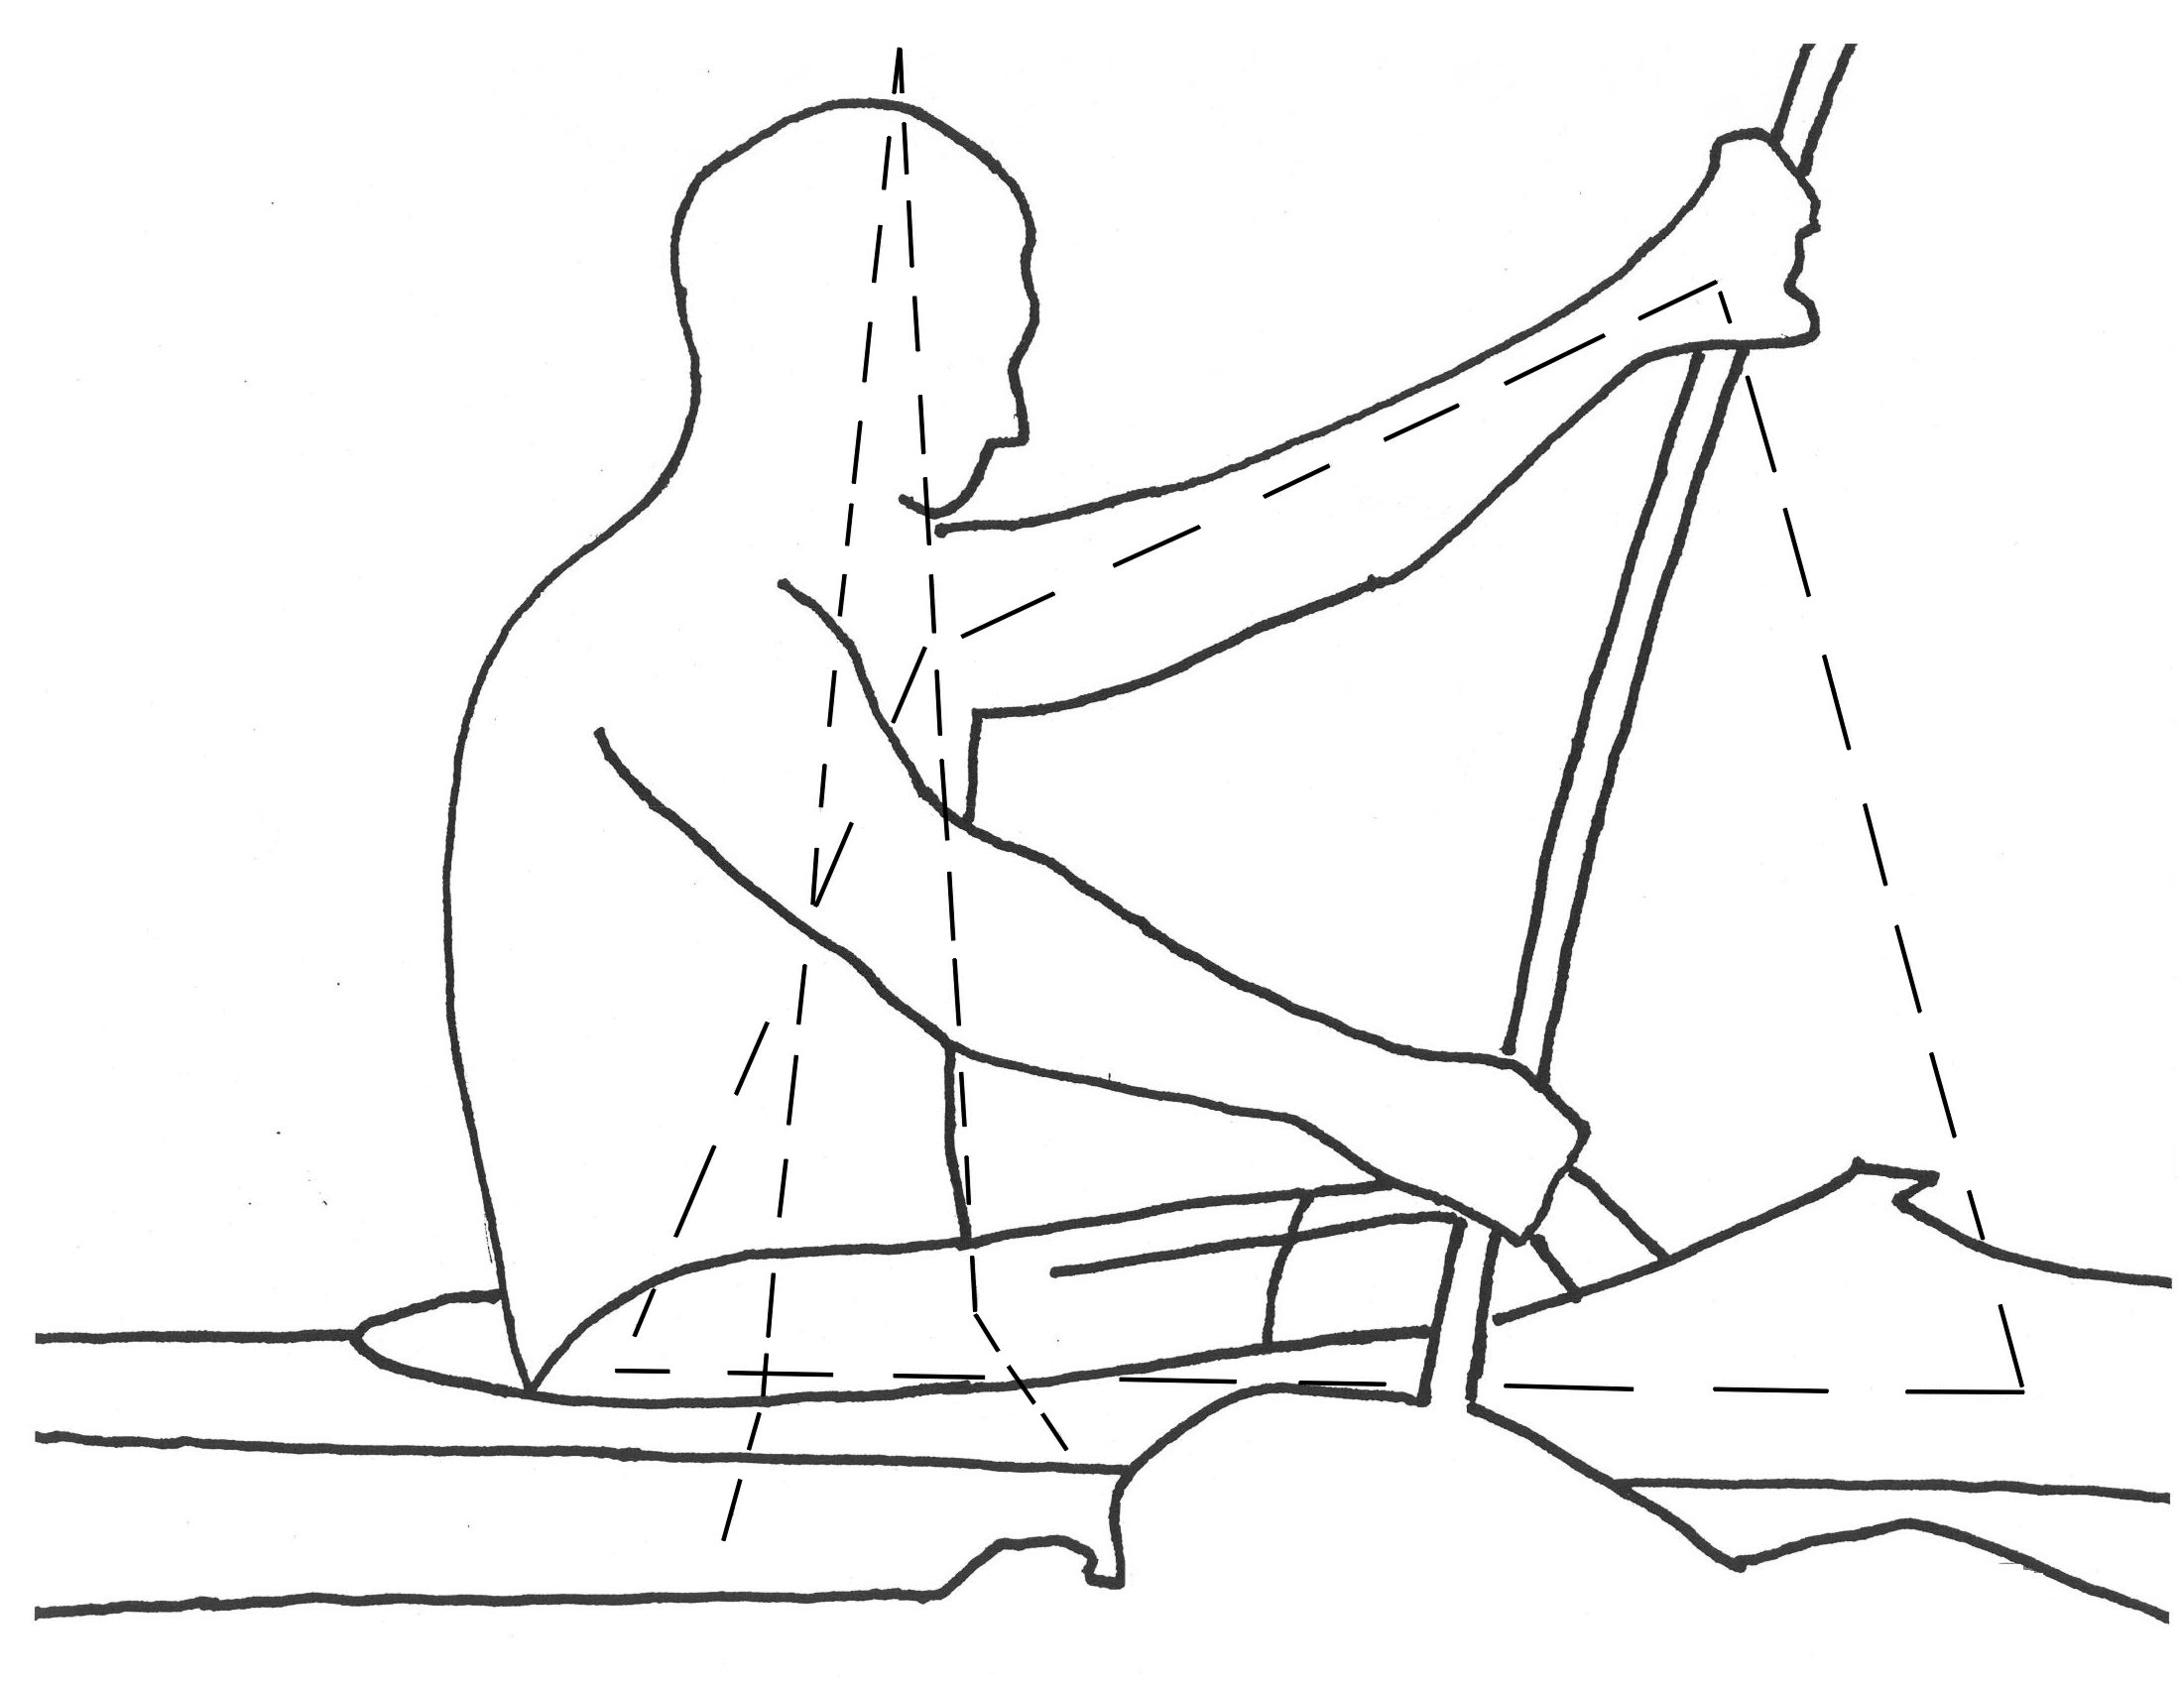
PC #5
→ foot board on the pulling side → straightening, contracting leg → hip on the pulling side → shoulder on the support side → supporting arm, hand → “back” to the foot board on the pulling side

Compression: foot board on the pulling side → straightening and contracting leg → hip shoulder on the support side → supporting arm → hand → “back to the foot board on the pulling side

Tension: none in this power circle

The Eiffel – Tower image always helped and still helps my athletes to “involve” swinging body weight (gravity) into the propelling of the boat. The Tower image can help to form the proper shape and direction of the “line of forces” that are bent at the feet, like the Eiffel – Tower, in order to form a very strong support for the structure of kayaking technique. In this case the “line of force” starts at the blade in the water, goes above the head of the athlete, down to the hip on the other side, through the wall of the boat and, finally, into the water wall.

PRACTICING: separately

